Something Awesome
Name: Joshua Eng Han Ruong
Student ID: 36340197
Date: 5 June 2026

Pitch
Short 25 words or less
Game design.

Longer Description
What I would like to present as awesome is not a single feature, but rather several that explore areas of programming not covered in this unit, all in the service of game design. In particular, I want to highlight the algorithm for generating the map and the method for ensuring balanced enemy spawns. If it is allowed, I would also like to write about the interesting aspects of my game from a game design perspective.

Learning Journal

Prior Knowledge and Experience
I’ll admit I’ve delved into these realms before. I’ve tried to program a few games in the past, although the only one I completed still isn’t much experience for the things here. Algorithms were not needed for it since it was a deck-building game with no progression, and I never got around to implementing enemy AI. The other games were all derivatives of games that already exist, with some minor modifications. In conclusion, I do have plenty of programming experience, but none with the awesome somethings I will write about below.

Iterations and Study to Create Project and Extend Capabilities
To complete this project, and extend my programming capabilities, I did the following:
<again, cut and paste this as often as you need. If it’s awesome, show us all the receipts! The material here should come from your H1 learning journal - look back and find the stuff you did that’s truly Awesome.>

Map Generation Algorithm
void game::generate_map()
{
int midline = 0;
int x_start = 0;
drawing_options opts = option_defaults();
this->map = dynamic_array<room *>();
room *starting_room = new room(room_type::BATTLE_LV1, opts, point_at(x_start, midline - room::ROOM_HEIGHT / 2));
dynamic_array<dynamic_array<room *>> layers;
this->current_room = starting_room;
starting_room->current = true;
this->map.add(starting_room);

dynamic_array<room *> first;
first.add(starting_room);
layers.add(first);

// Generate rooms
for (int i = 0; i < game::MAP_LENGTH - 2; i++)
{
dynamic_array<room *> layer;
int amount = rnd(1, game::MAX_MAP_HEIGHT);
int bottom_y = midline - (amount - 1) / 2 * room::Y_GAP;
for (int j = 0; j < amount; j++)
{
room *new_room = new room(room_type::random_type(), opts, point_at(x_start + (i + 1) * (room::X_GAP + room::ROOM_WIDTH), bottom_y + j * room::Y_GAP - room::ROOM_HEIGHT / 2));
layer.add(new_room);
this->map.add(new_room);
}
layers.add(layer);
}

dynamic_array<room *> last;
last.add(new room(room_type::BOSS, opts, point_at(x_start + 10 * (room::X_GAP + room::ROOM_WIDTH), midline - room::ROOM_HEIGHT / 2)));
layers.add(last);
this->map.add(last[0]);

// Link rooms
for (int i = 0; i < layers.length() - 1; i++)
{
auto current = layers[i];
auto next = layers[i + 1];

dynamic_array<int> available_to_layer;
for (int j = 0; j < next.length(); j++)
{
available_to_layer.add(j);
}

for (int j = 0; j < current.length(); j++)
{
room *current_node = current[j];
dynamic_array<int> available_to_room;
for (int k = 0; k < next.length(); k++)
{
available_to_room.add(k);
}

do
{
int connect_to = rnd(0, available_to_room.length() - 1);
current_node->next.add(next[connect_to]);
available_to_room.remove_at(connect_to);
for (int k = 0; k < available_to_layer.length(); k++)
{
if (available_to_layer[k] == connect_to)
{
available_to_layer.remove_at(k);
}
}
} while (rnd(1, 2) == 1 && available_to_room.length() > 0);
}

for (int j = 0; j < available_to_layer.length(); j++)
{
room *current_node = next[available_to_layer[j]];
dynamic_array<int> available_to_room;
for (int k = 0; k < current.length(); k++)
{
available_to_room.add(k);
}

do
{
int connect_to = rnd(0, available_to_room.length() - 1);
current[available_to_room[connect_to]]->next.add(current_node);
available_to_room.remove_at(connect_to);
} while (rnd(1, 2) == 1 && available_to_room.length() > 0);
}
}
}

My TA advised me to include a map of some sort in my game. Previously it was just a linear series of rooms. That meant I had to generate the map somehow. In one of the showcased submissions it was a simple free-roam map with randomly placed enemies, but that wouldn’t work in this style of game since there’s a progression of enemies and items. It also wouldn’t make sense to have a random free-roam section in a game that is otherwise pointing and clicking. So, I decided to generate a web of rooms with one-way connections between them, guaranteeing a set progression while giving choices to the player. Not every room connects to every other room, so the player must carefully plot their path. Battle rooms come in 4 difficulties, with higher difficulties spawning higher-tier enemies (not implemented yet) but giving better loot in return. Chest rooms give free stuff and merchant rooms enable trading in coins, but these rooms are uncommon.

My adventures in developing this algorithm are chronicled in the 30th May entry of the learning journal. This final iteration works by first generating a random set of rooms to fill each layer. The layers provide a defined progression, as opposed to having rooms all over. It enables players to easily see the way forward and check the paths they could take. The rooms are also physically positioned in this stage. After this, linking occurs in two stages per layer. In the first stage, each room in the layer is linked to a random room in the next layer. There is also a repeatable 50% chance to link to another random room. The interconnectedness of the map can be altered by tweaking this value. This may leave rooms with no room linked to them, so which rooms are not linked to are tracked. In the second stage, linking goes backwards. The linkless rooms are connected to a random room in the previous layer, again with a repeatable 50% chance to link to another. Due to the structure of the game all room links are “forward” regardless of the direction they were defined in.

It was very satisfying thinking of this solution. Although I have no doubt there are optimisations that could be made, I find the concept behind it to be an elegant solution, especially compared to my previous ideas. From this I learnt to try to think about tough problems from a different point of view. In this case, that meant generating rooms and links in different stages instead of all at once which greatly simplified the process. As a byproduct I also learnt to not use unnecessary complexity. The rooms were originally a linked list, with function calls propagating forward from the first room. It became simpler to put them into a list and iterate over it instead. Frankly I should’ve done that first instead of trying to be clever.

This experience also showed the importance of iterative development. For the original algorithm I planned the whole idea in my head and tried to implement it all at once. Of course, there were bugs, lots of them, and I didn’t even know where to start since there were many places in the freshly-made algorithm where they could’ve been introduced. This was mostly what motivated me to try and find an entirely different algorithm, so I wouldn’t have to spend ages debugging. If I only implemented the core parts of the algorithm and slowly built up from there, maybe the original idea would’ve ended up working.

Enemy Spawn Balancing
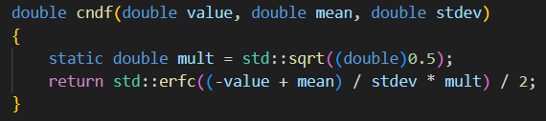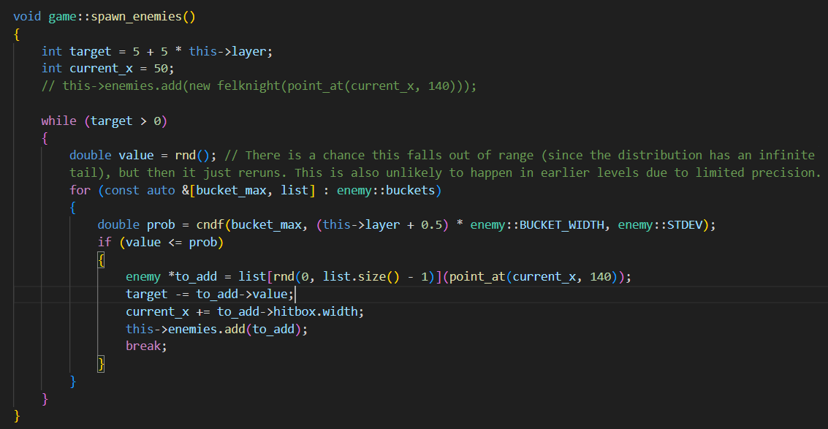
This one can be a screenshot since it’s small enough to fit. Thinking of and implementing this is described in the 1st June entry of the learning journal. Although not very technically complex, I think it’s a pretty neat solution. It also pulls on mathematical concepts outside this unit to enhance the game experience.

The problem is one of balancing. So the rooms don’t become monotonous, they should contain a variety of enemies, However, enemies have different stats, with some supposed to only spawn later and some earlier. The best way to reconcile these two requirements, in my opinion, is for enemies to define a range of layers they can spawn in and a preferred layer. Then, the chance of them spawning in a certain layer drops the further from the preferred layer it is. I considered a few solutions. The first was to manually define each for each enemy, but I felt that introduced unnecessary complexity. Each enemy was tuned to a specific point in progression, so their spawn range width should be very similar. I also thought I might run into issues with normalisation, i.e. calculating the relative probabilities of each enemy in each room. Thus, I opted to go for a normal distribution, which always has a cumulative probability of one and is purely defined by its mean and standard deviation. The expected enemy value for the layer can be used to calibrate the mean, and the standard deviation can be a constant which affects enemy variety when tweaked. Importantly, the property of the chance of spawning decreasing further from the preferred layer is kept. The normal distribution also occurs in many real situations (see also the central limit theorem), so hopefully the resulting enemy variety would feel natural.

That left the problem of implementation. My original idea was to just use the formula, but I hoped to use the cumulative probability function to make it easier to use a raw random value between 0 and 1, as is returned from Splashkit’s rnd function. After some research, it turned out that was computationally quite difficult, so after looking at a handy list of approximations on the Wikipedia page I opted to use an Irwin-Hall distribution, very similar to the normal one but can be computed by simply averaging random numbers. It wasn’t cumulative, but it would do. However, I was somewhat unsatisfied and pursued the cumulative idea, landing in a StackOverflow thread that had a code snippet to calculate it, which I used in the cndf (cumulative normal distribution function) function. I set the maximum enemy value to 45, and a random value would be chosen from 0 to there according to a normal distribution tweaked to fit the current room. Not every value would correspond to an enemy, so I separated the values into buckets of width 5 instead. If the value landed in a bucket, a random enemy would be spawned from that bucket.

Tooltip Monads
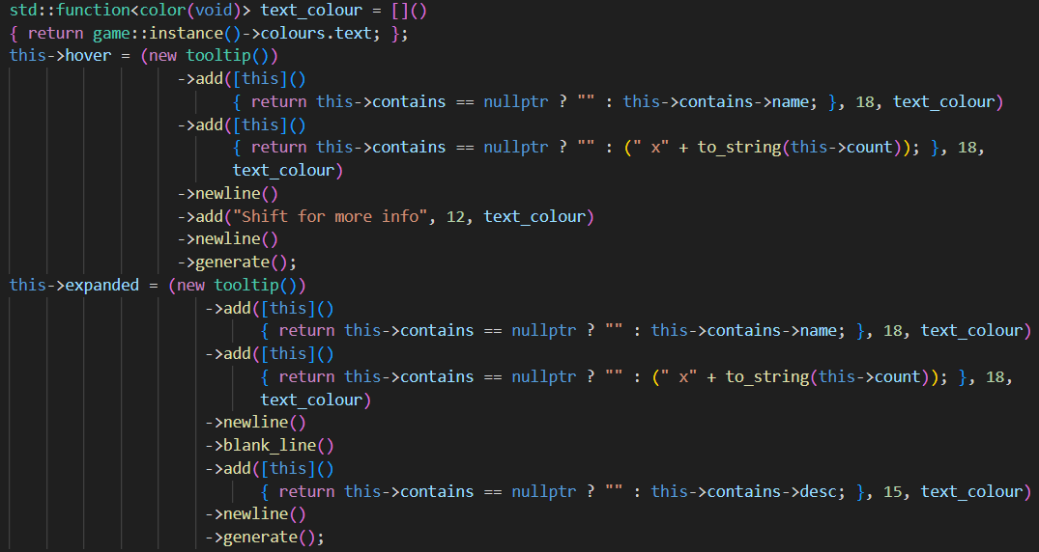
As mentioned in the 29th May entry of the learning journal, I like monads. They enable a very intuitive reading of the composition of objects, if used in the right place. In this game, tooltips (pieces of text that appear on the mouse to provide info while hovering) are implemented as monads. They are composed internally of multiple parts and, since they are used by many parts of the game (in the future), must be heavily customisable. I also wanted to avoid the overhead of drawing so many individual parts every frame, so the tooltips are pre-generated on a bitmap and that bitmap is displayed, it being regenerated manually if the values contained within change. In hindsight, this was a bad decision. The overhead is probably negligible, even more so in a program like this one with mostly static graphics, and now there is a requirement for manually calling the regenerate function in a bunch of places. Premature optimisation and all that. The concept worked well, though. The only thing was that almost everything had to be wrapped in a function, to allow custom logic like null-checking. The monad is also perhaps a bit more verbose than required, with there being a distinction between newlines and blank lines, and the newline function needing to be explicitly called at the end of every line. The last one was necessary since a line might be composed of multiple text parts, such as to switch colour halfway. I thought of implementing automatic text wrapping but that’s just for quality of life, so I defer it for now.

Game Design
I am aware this is a programming course, not a game design course. However, the criteria mentioned things like having a high degree of personal ownership, which I take to mean an interesting and original concept, since there are not many exciting things to be done with the code itself at the level of this course. I suppose it could also be that the code was overwhelmingly written by me, but I still want to talk about game design.

Line Boil is unique due to the presence of the eponymous mechanic, line boil. The lines are supposed to boil using Splashkit’s animation system, but I didn’t end up having enough time to draw all the alternate sprites. Boil acts as a separate HP bar of sorts, one that ticks up instead of down. It also passively accumulates (not implemented yet) every room, making it a price for fleeing or going through a merchant or chest room. Fleeing in particular exacts a second price as well, since you don’t get the loot from remaining enemies. This may lead to being underprepared for the boss, the only non-fleeable encounter and a mandatory prerequisite to winning. This is uh… also not implemented, but the infrastructure is already there. Of course, more difficult enemies give better loot, incentivising players to choose more difficult rooms (indicated by its icon) if they think they can handle it. I like to front-load my development process as much as possible, making overly extensible systems for later. Getting hit increases boil, while defeating enemies reduces it. These values are different for each enemy, requiring some strategy to know when to flee and what order to defeat enemies in.

When the boil meter fills, the player immediately dies. Having a second death condition like this greatly alleviates a certain problem caused by accessories. There are over a dozen attributes accessories can modify, but only three attribute slots. This means each accessory must be impactful and powerful on its own, but then if multiple of the same kind are stacked the resulting build may be overpowered. This affects defense percentages in particular. It is very possible to get a 100% damage or boil reduction. The important part is getting both is not possible, or at least incredibly difficult. Thus, players who go for one will die to the other. This encourages balanced defensive builds, or offensive-focused builds. Offensive builds don’t suffer from this problem since their weakness is making the player a glass cannon, requiring careful management and prone to dying to an unexpectedly tough enemy.

Wrap Up

Showcase Video Link

Link to any related resources

Reflection

What is the most important thing you learned from this and why?
Its difficult to say there was a single most important thing. What I learnt from this is split up into small but nevertheless useful bits here and there. I did learn a lot about the language, such as inheritance, standard library types, the various strange errors and conditions like how references always have to be initialised, and the subtleties of language features like consts or constexprs, or headers and their guards (and preprocessor directives in general). Language-specific knowledge will be useful if I choose to code in C++ again in the future, but logical things like regarding the normal distribution, the map generation algorithm, and architecture knowledge like spamming singletons everywhere and passing references versus global singletons, will likely find use in future projects or work.

References
None, unless I must cite my learning journal?

Generative AI acknowledgement
No generative AI was used in this task.

